**Changing U2 on main PCB of SVT-7 Pro**

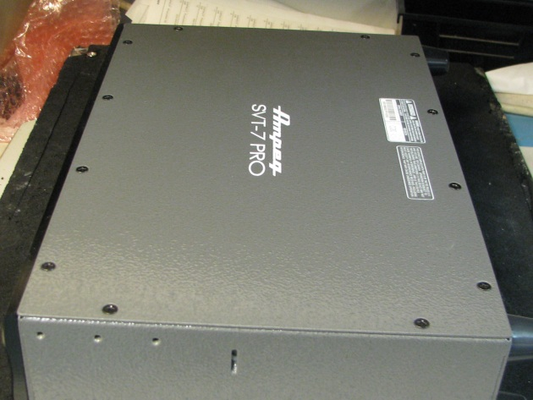

1. **Locate screws on chassis top**

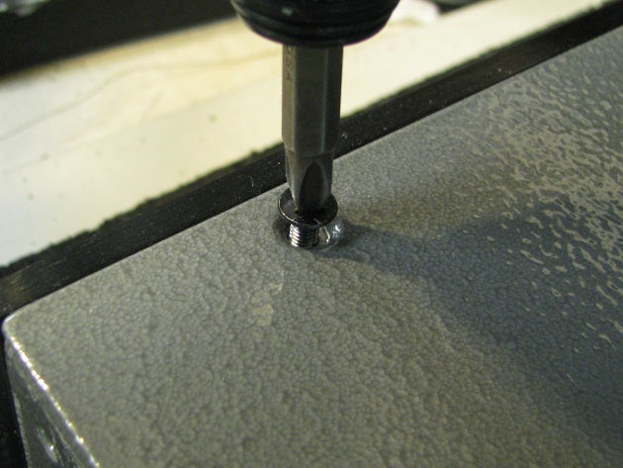

1. **Remove screws from chassis top**

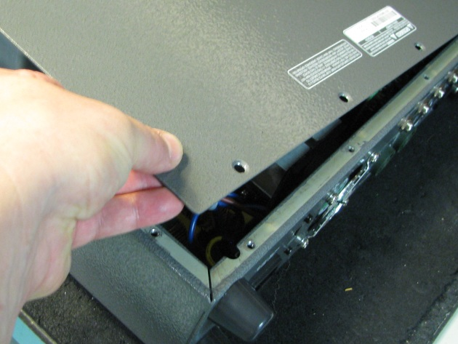

1. **Remove chassis top**

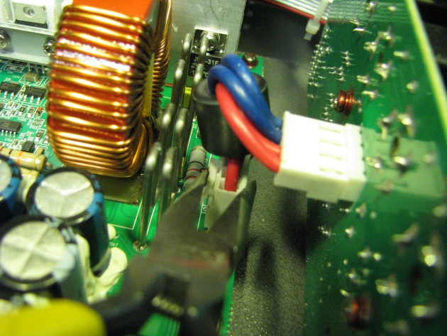

1. **Disconnect cable at J1 of main board**

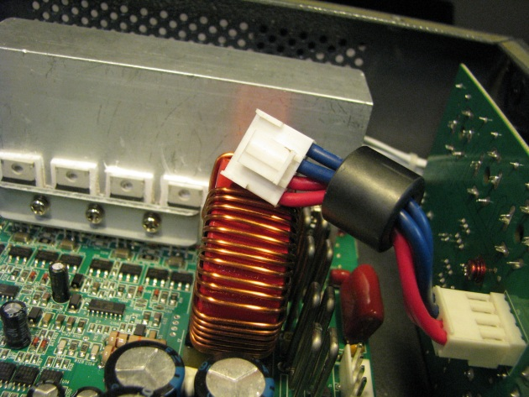

1. **Cable disconnected at J1**

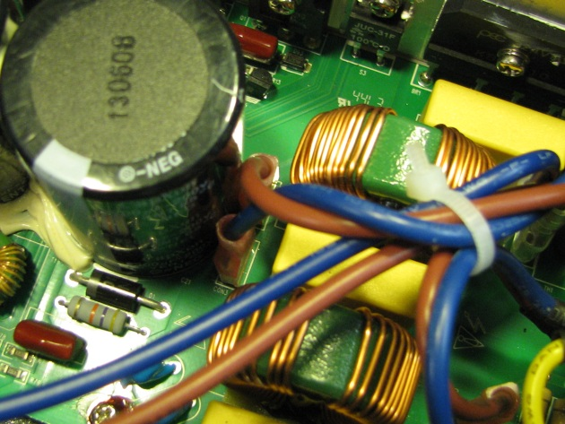

1. **Locate blue and brown wire to Con3 and Con4**

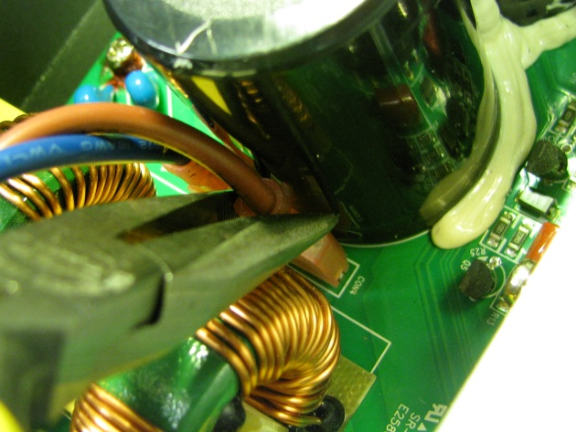

1. **Using needle nose pliers disconnect wires at Con3 and Con 4**

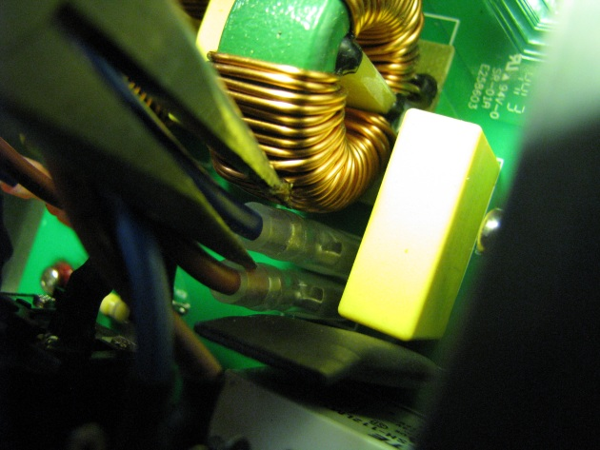

1. **Locate and Disconnect wires from Con1 and Con2**

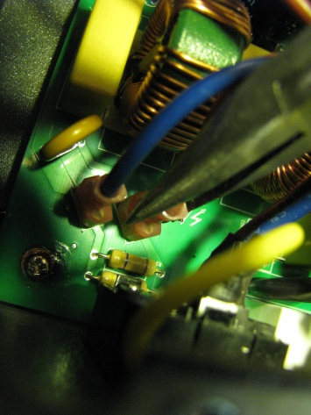

1. **Locate and disconnect wires at Con5 and Con6**

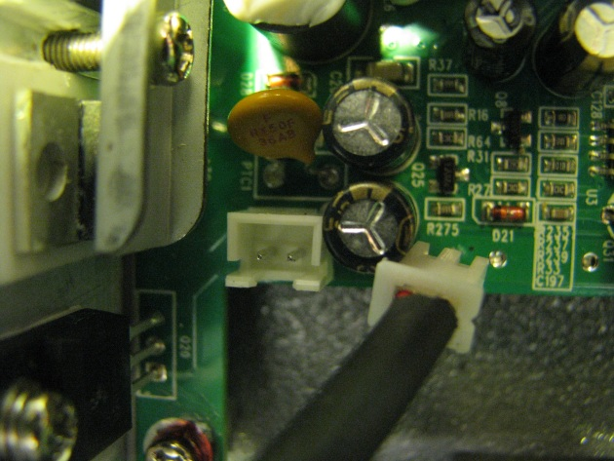

1. **Disconnect fan cable at J22**

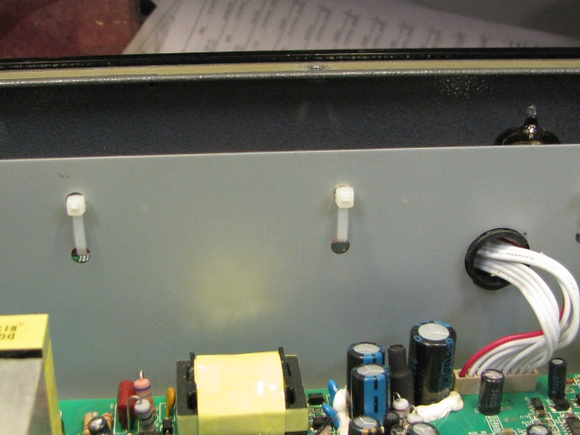

1. **Locate ties at front panel shield**

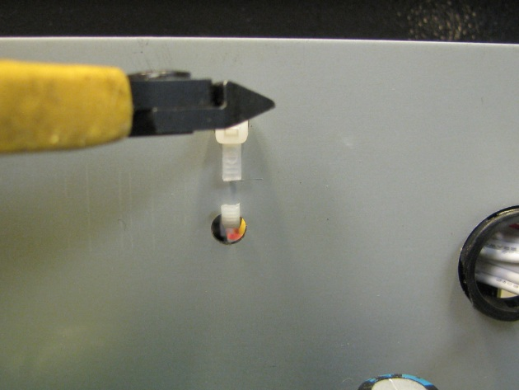

1. **Cut these two cable ties**

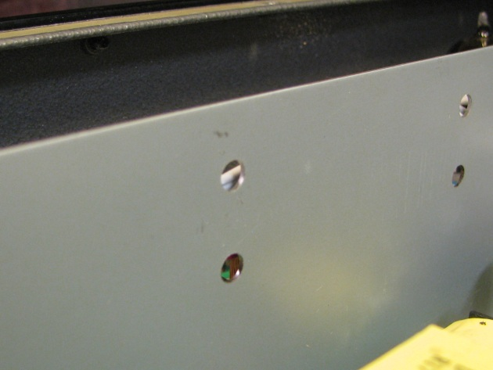

1. **Remove cut cable ties**

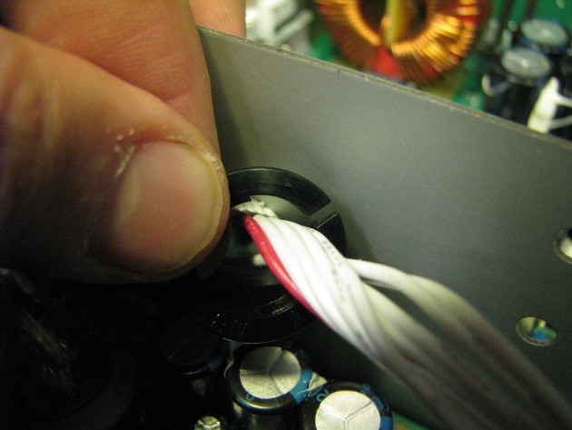

1. **Cable at J13 on main passes through front shield. Remove plastic grommet.**

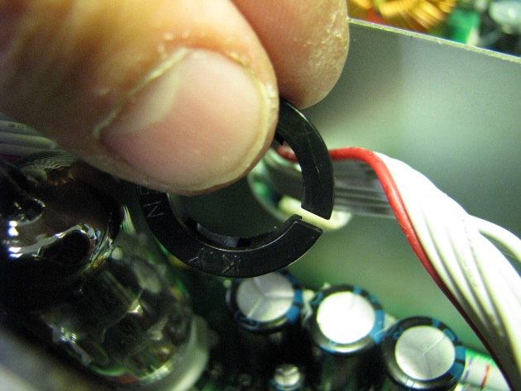

1. **Take grommet off cable**

**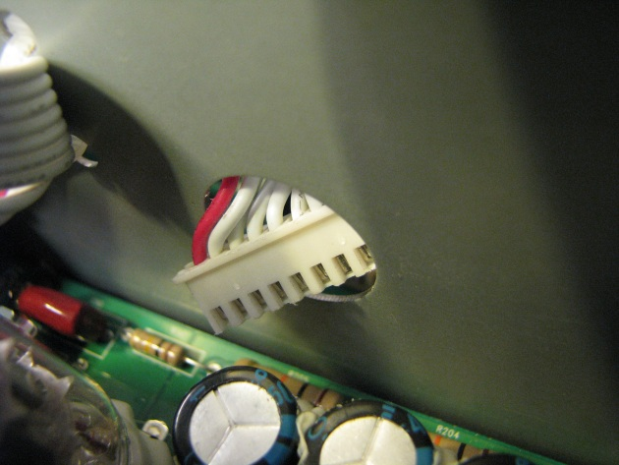  
16. Slide cable through hole.**

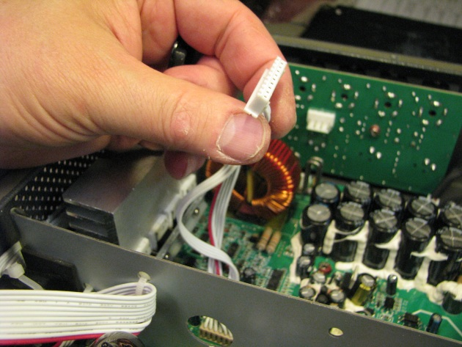

**17.Cable to J13 is now free from obstruction**

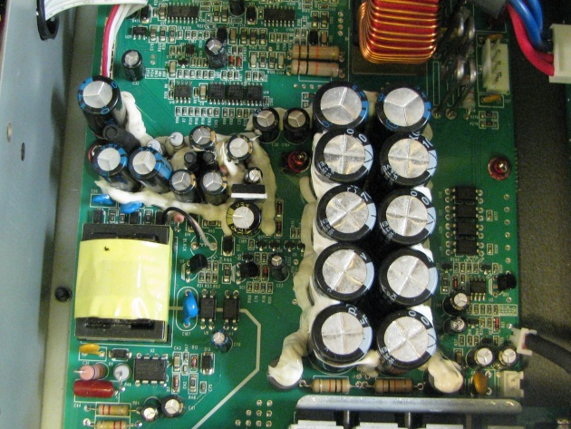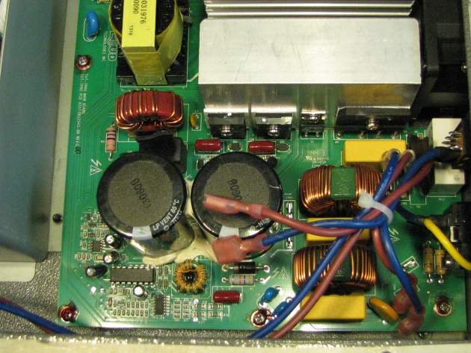

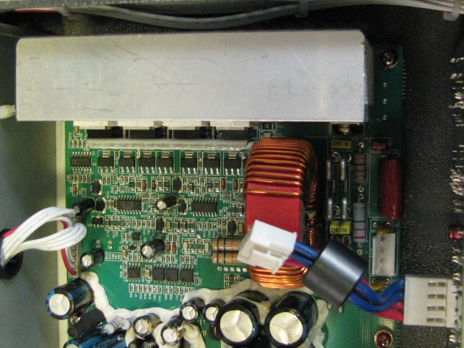

**18. Locate screws holding PCB to chassis.**

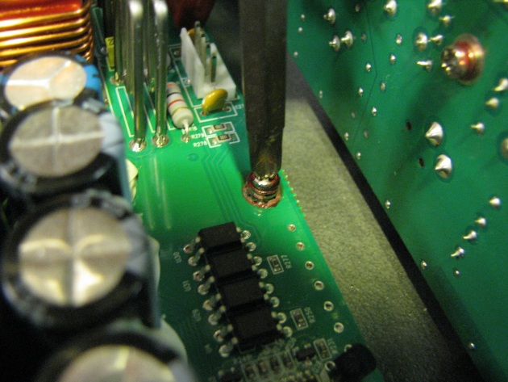

**19.** **Remove screws holding PCB to chassis**

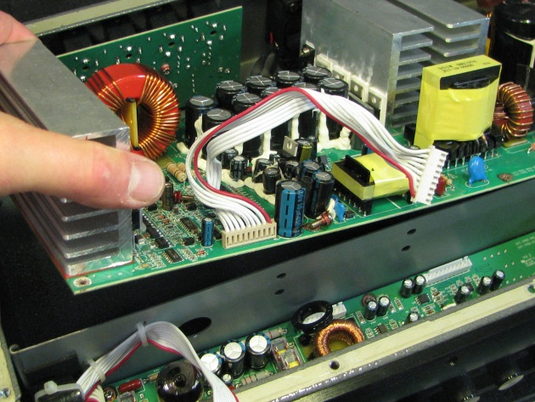

**20.** **Remove Main PCB assembly by lifting front part of PCB**

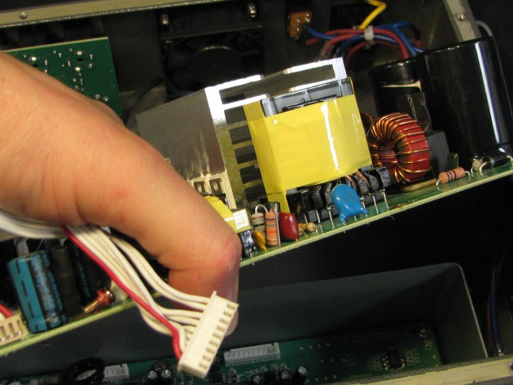

**21.** **Main assembly removed by lifting and pulling forward to allow power wires to clear rear portion.**

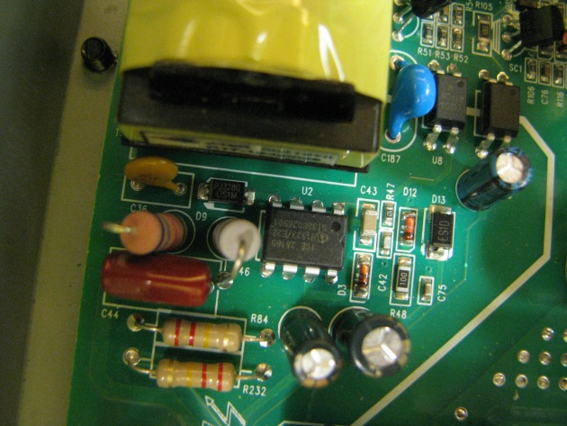

**22.** **Locate U2**

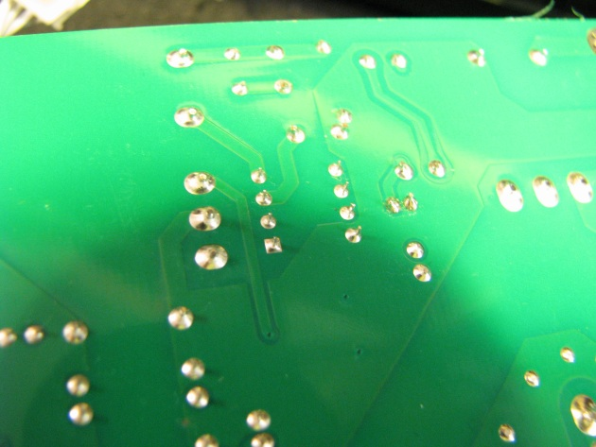

**23.** **Locating U2 pins on bottom of PCB**

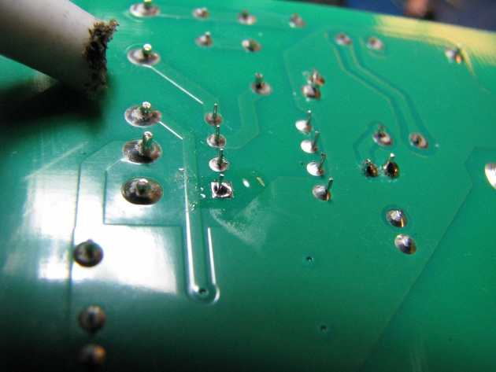

**24. Unsolder and remove U2. Replace U2 with new improved part #....**

**25. Reassemble.**